**GIT & GITHUB – 01**

NAME : Pallavi Nimmala

Date : 10/16/2023

**WHAT IS GIT AND GITHUB??**

**GIT**:

Git is a version control system that lets you manage and keep track of your source code history.

**GITHUB:**

GitHub is a cloud-based hosting service that lets you manage Git repositories.

**DIFFERENCE BETWEEN DISTRIBUTED VERSION & CENTRAL VERSION CONTROL??**

**Version Control:**

Also known as Source Control. It is the practice of tracking and managing changes to software code.

Centralized VC Distributed VC

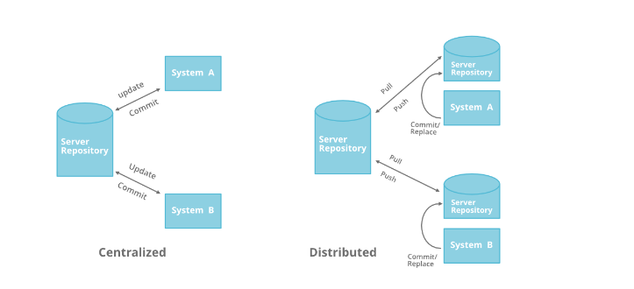

**Set of GIT Commands….**

1) To Set global user_name

Git Config --global user.name "Pallavi Nimmala"

2) To set global user_email

Git Config --global user.email "pallavinimmala01@outlook.com"

3) Initiliaze git

Git init

4) To add files to tracking area

git add file_name

5) To add multiple files to tracking area

git add .

6) To check Direcotry status

git status

7) To Commit files

git commit -m "Message"

8) To push changes to central

git push -u origin master

9) To add remote origin

git remote add origin <git_repo_url>

10) To view the remote origin

git remote -v

11) To make a copy from central to local

git clone <git_repo_url>

12) To pull the latest changes to local

git pull <git_repo_url>

13) list of branches

git branch --list

14) To create branch

git branch <branch_name>

15) To checkout branch

git checkout sabear

16) To push code to specific branch

git push -u origin <branch_name>

17) To view git logs

git log

18) To view last 3 logs

git log -3

19) To revert any previous commit

git revert <commit_id>

20) To merge two branches

git merge <branch_name>

21) Clone one particular branch

git clone -b <branch_name> <github_repo_url>

22) Git stash is used to push files to stash memory

git stash

23) To view the stash list

git stash list

24) To get files out of stash memory

git stash pop

25) To get a specific file out of stash memory

git stash pop stash{id}

26) TO copy specific commit to other branch

git cherry-pick <commit_id>

27)To revert the deleted files before Commit

git revert <commit_id>

28) To move again from tracking area to untracking area

git reset

## I have created a repository to push all tasks documents of mine to Github repository .

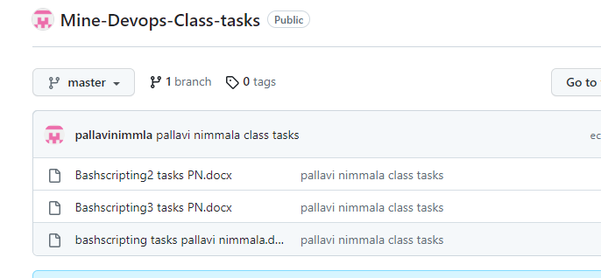

**STEPBYSTEP PROCEDURE TO PUSH TO REPOSITORY :-**

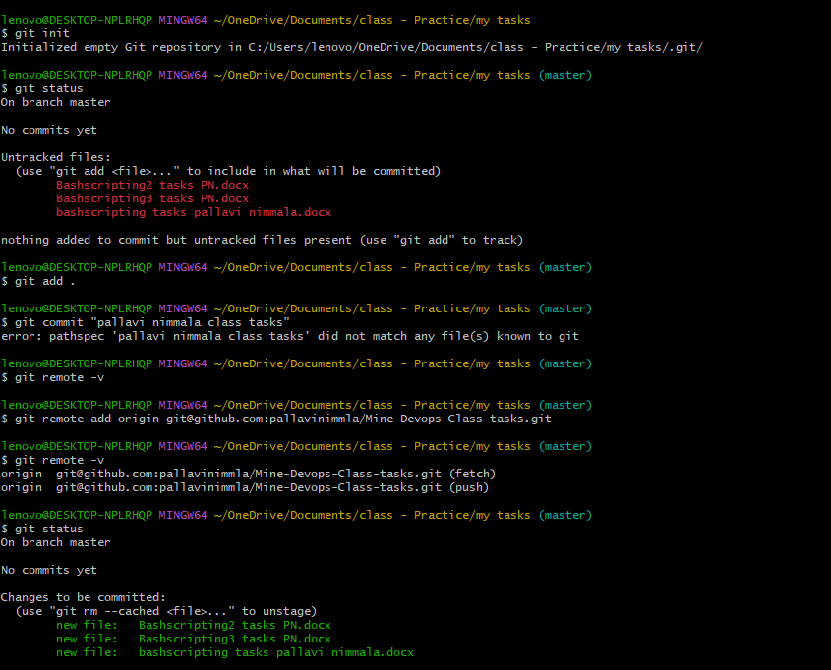

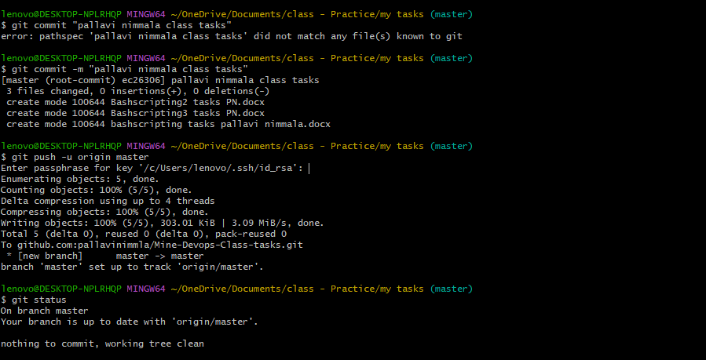

END